14.47: The acceleration due to gravity on the planet is
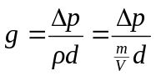
and so the planet’s mass is
